Applying the Machine Learning via TensorFlow and Matlab in Heat Exchanger experiment:
What you already have:
- Temperature measurements for hot and cold water at inlet and outlet
- Properties of the water at given temperature (through table)
- Flow rate of hot and cold water
- Overall heat transfer coefficient based on LMTD and NTU method (the output values of your experiment)

What you will be provided with:
- A computer with Tensorflow code using python libraries via Github
- Dataset from the experiment in CSV file format
- Access to Machine Learning and Deep Learning Toolbox in MATLAB
What you will execute:
- Google Colab Environment:
- Run the code
- Plot the following charts:
- MSE vs Epoch
- MAE vs Epoch
- Predictions vs test values
- Error Distribution for U_{LMTD} and U_{NTU}
- MATLAB Environment
  - Follow the steps given in this document and
  - Plot the following charts:
- Response
- Predicted vs Actual values
- Residuals
- Minimum MSE
(Important: For MATLAB, you need to run the program twice as it can handle only one output either U_{LMTD} or U_{NTU}.)

TensorFlow Steps:

- Understand your data, what are the inputs and what are the outputs. Avoid fixed parameters like heat capacity which does not change with temperature.
  - Inputs: $T_{h(in)}, T_{h(out)}, T_{c(in)}, T_{c\left(out\right)}, ρ_{in}, ρ_{out}, {\dot{V}}_{in}, \dot{V_{out}}$
  - Outputs: $U_{NTU}, U_{LMTD}$
- Upload the data:
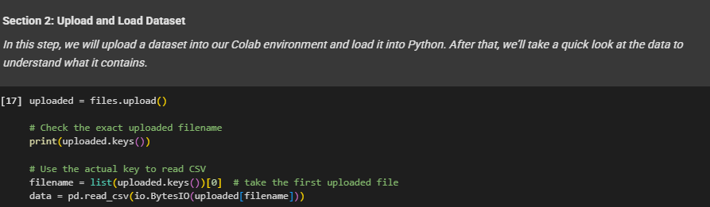
- Differentiate the inputs and outputs from the uploaded CSV file:
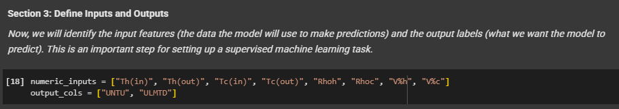
- Split your data into training and testing sets:
    - Use 80% for training the ML model.
    - Use 20% for testing/validation.
(You may also try 85-15%, etc., and compare results.)
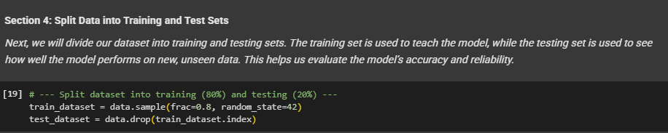
- Prepare your data for Machine Learning:
Normalize your data (scale input features so they have similar ranges, e.g., between 0 and 1).
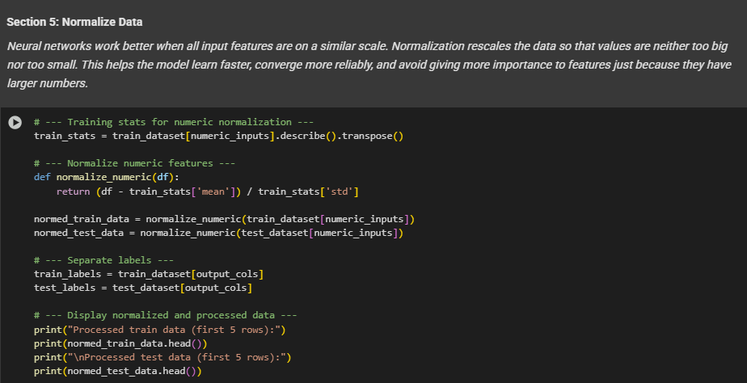
- Build a Simple Neural Network Model in TensorFlow
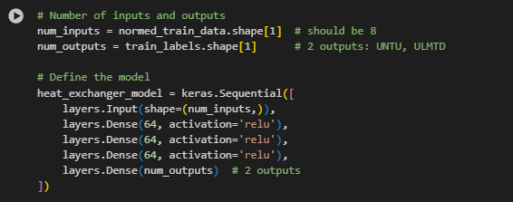
You can see in the above screenshot that we have three hidden layers with each layer having 64 neurons with ‘relu’ as the activation function. You may change the architecture based on your choices.
(vii) Compile the model
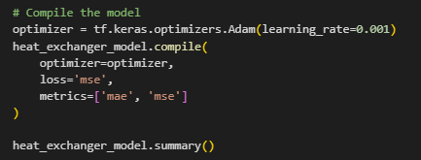
- Train the model
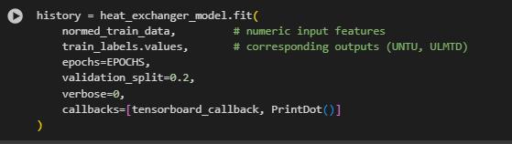
- Plot the MSE and MAE metrics with respect to epochs:
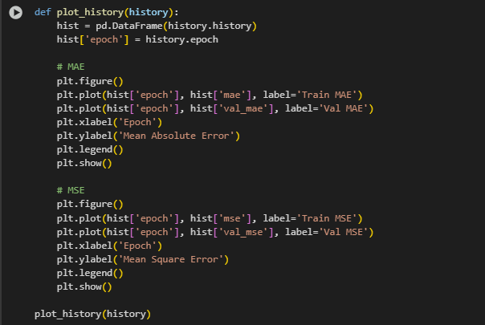
- Plot remaining graphs of predictions vs test values and error distribution.

MATLAB Steps:

Step 1: Import the data (i.e. CSV file)
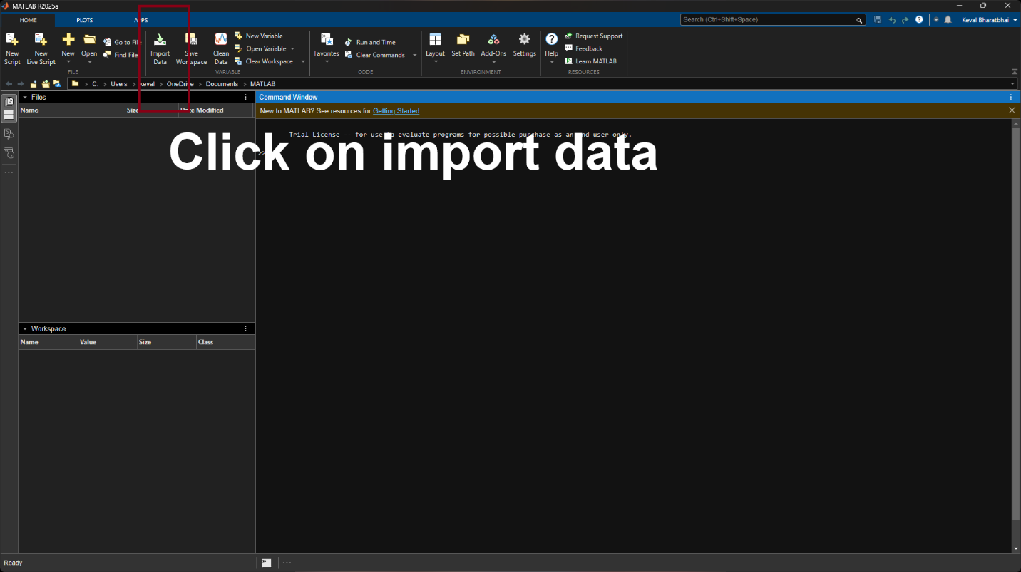

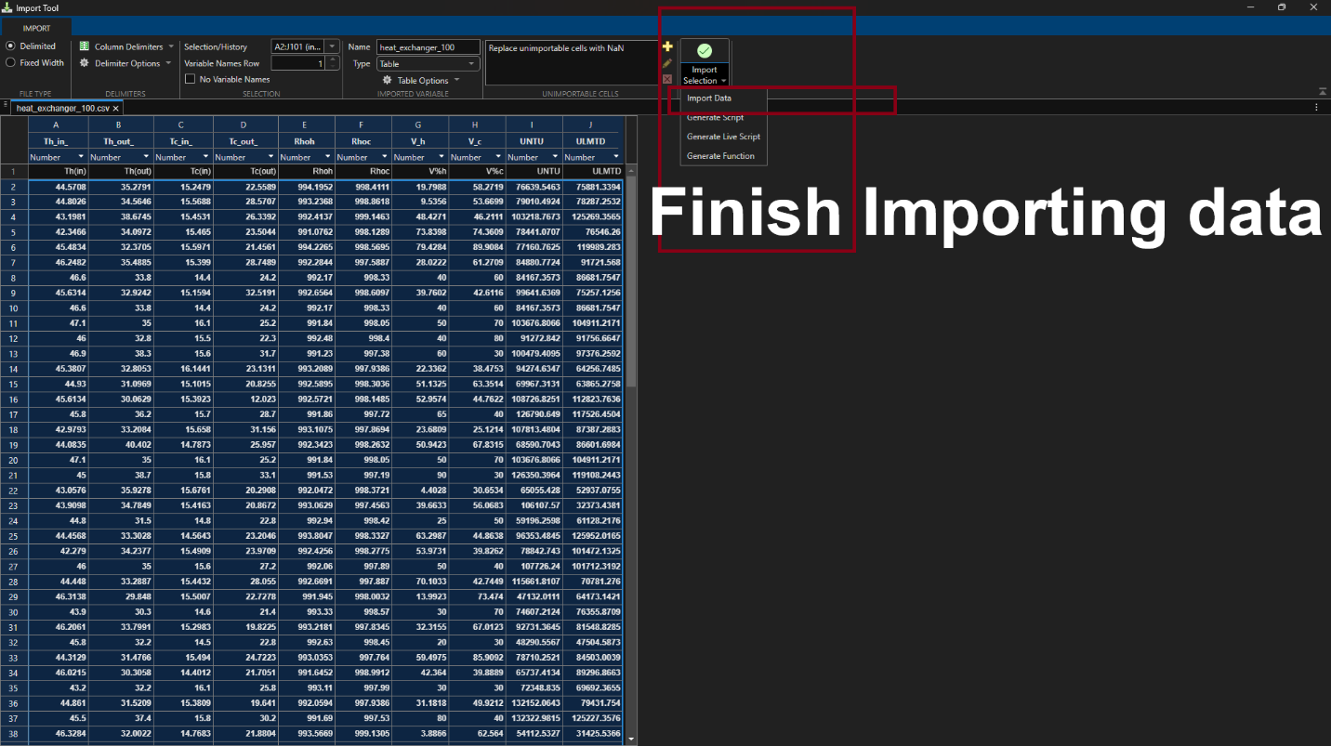

Close the import tool.

Step 2: Go to APPS and then find MACHINE LEARNING AND DEEP LEARNING section and select REGRESSION LEARNER.
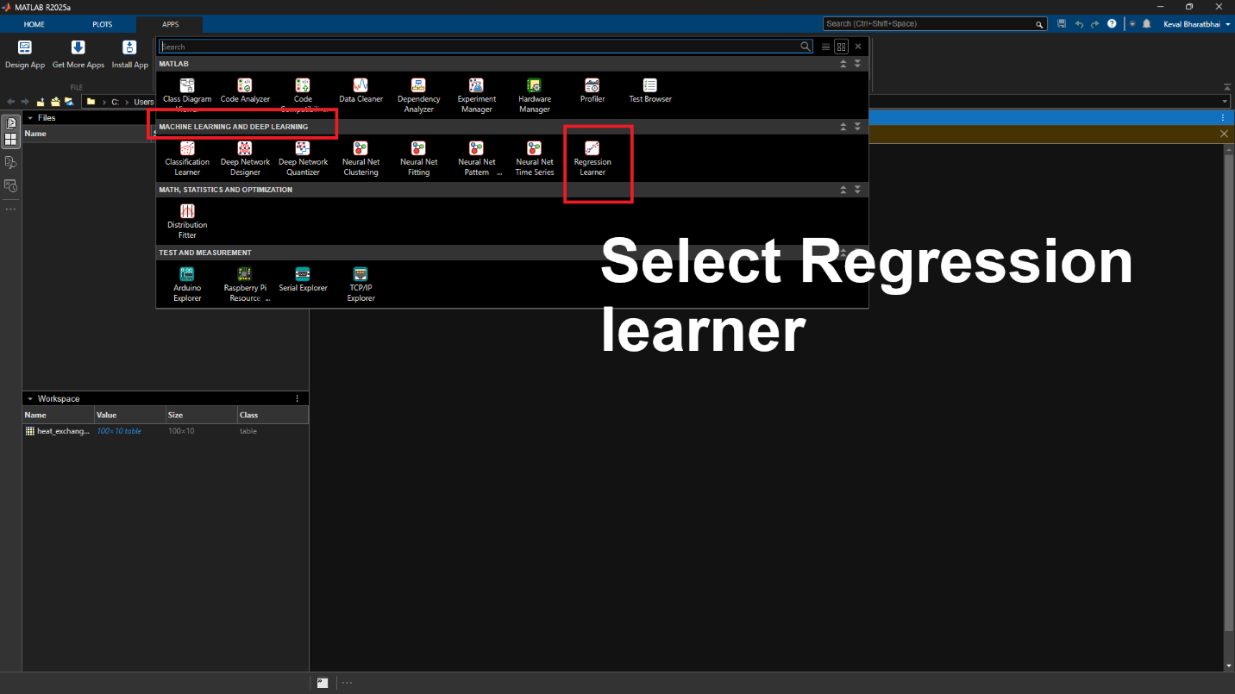

Select New session and then “From workspace”,

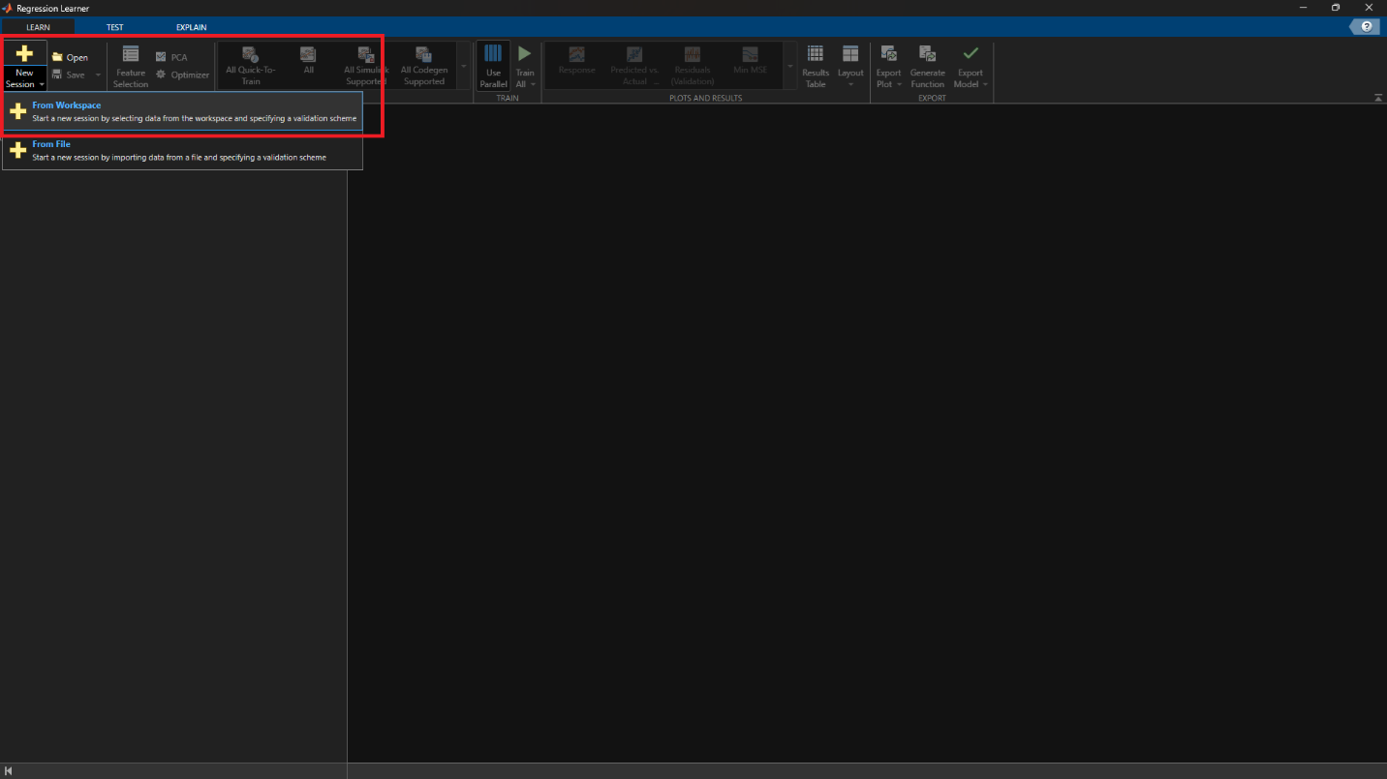

Step 3: Select the input variables and the output you wish to predict (either U_{NTU} or U_{LMTD}).

Keep Cross-Validation folds to default value of 5.

At this stage, we decide the division between training and testing. At the right bottom, select “Percent Set aside” as 20 or any other value you wish.

Make sure to uncheck U_{NTU} and U_{LMTD} as predictors.
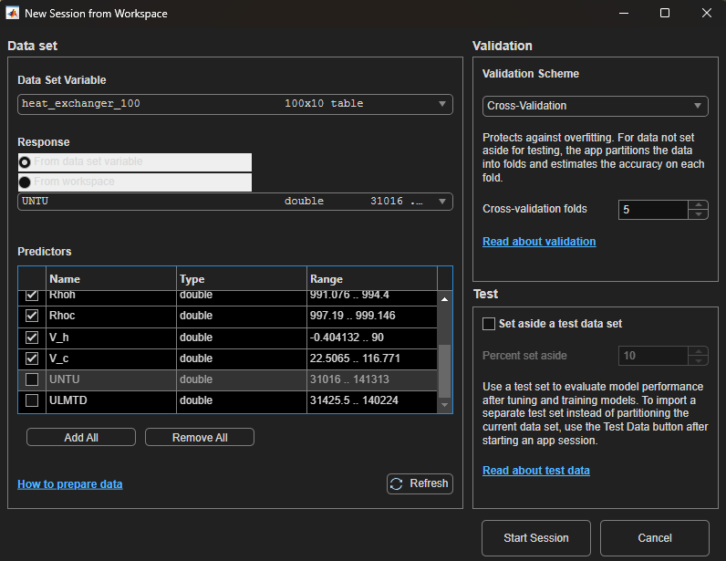

Step 4: Under the Models section, select Optimizable neural network available at the bottom of all.

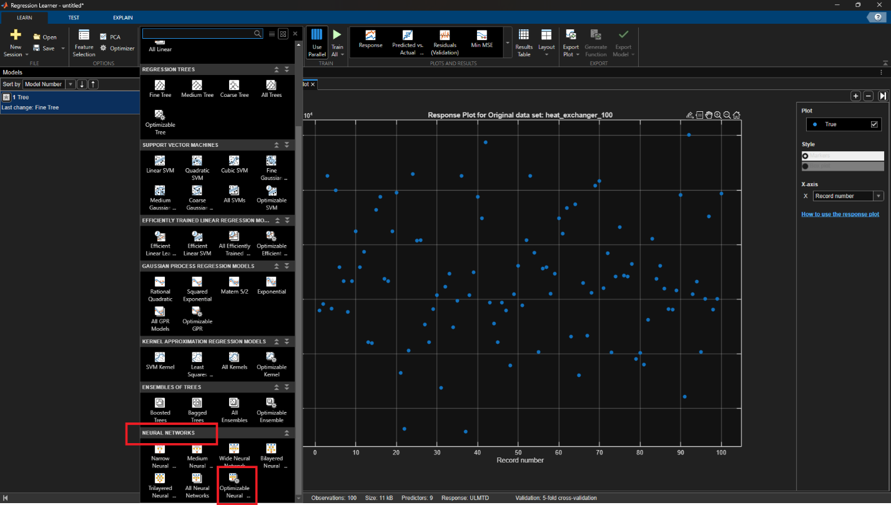

Step 5: Change hyperparameters as per your choice, make sure to update the predictors.

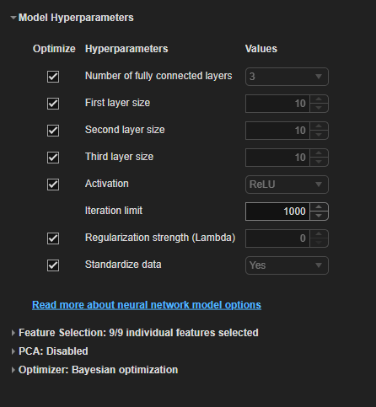

Step 6: Train the model:

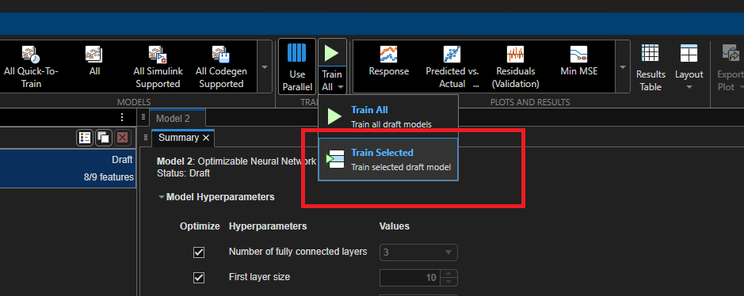

Step 7: Save the validation and optimization results.
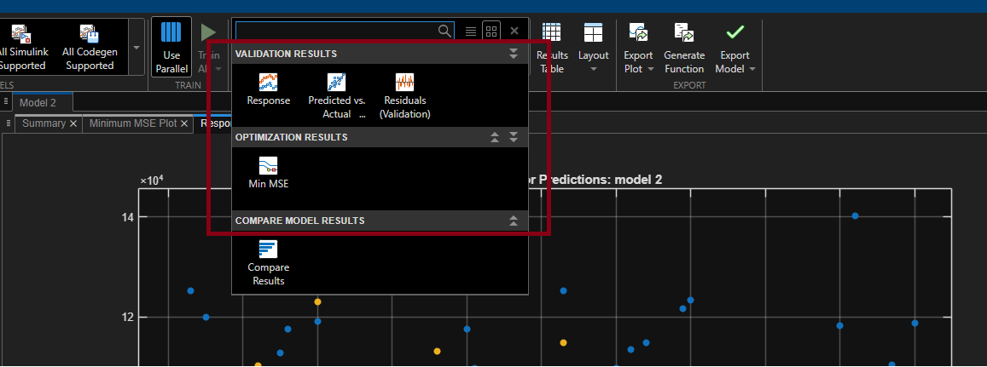

Discussion:

Which method (NTU vs LMTD) gives more accurate ML predictions?

How do TensorFlow and MATLAB results compare?

What are the limitations of these ML models?

Lab Report Requirements

Plot the comparison between the two tools you used:

- MSE vs Epochs (iterations)
- Actual values vs predicted values. (For both NTU and LMTD method)

